oh so the easy way is to check local token if that exists then redirect to orders page if deosnt exist for this app then red diecet to phone numeb page whihc is same for reislateld suers and new users same opt verifaiton. then this numebr is chekced in database if exists then redirecet to orders (ie returing user after reinstall) . not exists then firs time user redirect to name entering
but now two things where does local token be stored ? in db or what? seocndly does the local toekn also consits of user id ? because how will i know whihc user it is if i odnt ahve the user id

Just check local token existence in the db . if it exists then redirect to orders
If it doesn’t then make them enter phone numeb and verify otp
If phone number exists then reidriect to orders page
If it doesn’t then redirect to name entering page

LOGIC:
OTP will be generated and sent by backend to the email/sms and

FUNCTIONS:
Check session:
Will check if the local session token exists in the database or not
If it doesn’t exist that implies, either the user is new or the user is re-installing the app

Phone number_exists fn:
Checks if the entered number already exists in the users table if it does, then set the verified Boolean to false in the user_id table : the user already exists but has to undergo verification of phone number again
Checks if the entered phone number exists in the pending users table, if it does then do nothing , if it doesn’t then insert the number (This will be done for existing users too that are getting back to the application as they are currently pending (unverified) users too

Store otp:
Stores otp in the pending users table
If the otp already exists then upates the otp (can be because the user exited during the process came again, or that he requested a new otp)

Verify_otp_and_activate_users fn:
Checks the entered otp against the stored otp
If passed:
If new user, inserts the info from pending users table to new users table
If existing user (re-installing the app), sets verified to true

12/01/2026
Logic:
If both session and role exists: Go to orders page
If session doesn’t exist: Enter and verify phone number, after which session token is created
If session exists, but role doesn’t: Enter the fields for the user, regardless of the role
Role will be assigned based on where the query came from. The backend will handle this

The common steps for all the users uptil OTP done.
All the steps for each user done till registration, verification etc
Customer and Driver: One additional page for entering fields, different procedures for each
Supplier: Two pages and therefore two procedures, one for entering fields and the other for entering the cnic images

Working on suppliers now.
Upon entering the orders page, first his existence in the supplier_Drivers table will be checked, if he doesn’t exist there therefore he hasn’t defined one single driver, implying he is a new registration.
This will cause him to be prompted to enter his driver phone numbers first
After entering phone numbers, he will have orders page inaccessible UNTIL one of his entered phone numbers of his drivers have not entered the application or has not logged in here.
This will be checked by checking the supplier drivers table again against the suppliers user id, and checking the driver_user_id there. If atleast one of them is not null he can view the orders page. Until then, the orders page remains inaccessible.

Made a trigger for drivers:
It will check if the removed session row is of driver, if it is then it will set the driver’s id in supplier drivers table to null only
When he comes back to the application, after verification, his session will be generated, upon entering his details it will be checked that if his role is already set to driver that implies he is an existing user therefore only set his id back into the supplier drivers table.

So updated the enter deitals driver fn to remove re-linking of driver_id to the supplier_drivers table
Made a new trigger of re-link_driver_after_session generation
This will check that after a new row has been inserted into sessions table check if the user has role defined as a driver (role defining is the absolute last step for each user after registration)
if it has then that means his details already exists jsut need to link his id to the suppliers table again

13/01/2026:
Working on suppliers
Check_supplier_has_drivers fn: Checks if the supplier has logged in for the first time
If he has then he will be prompted to enter driver phone numbers
This will be checked by checked the supplier_drivers table

Check supplier_has_active_drivers: This will check if any of those drivers declared by that supplier are active
This will be checked by checking the supplier_id and the driver_id against that supplier in the supplier drivers table
If, for that supplier_id, even if one of the driver_id is not null, then that means atleast one of his drivers is active
He can access the orders page

Let me clarify step by step:
What is a Channel?
A channel is like a radio station. PostgreSQL can broadcast messages, and Node.js can tune in and listen.
- 'orders_channel' = The radio station name (you can name it anything)
- 'update' = The message being broadcast (just a simple text saying "something changed")

The Complete Flow:
Step 1: Order is created/updated

Step 2: Trigger automatically fires

Step 3: Function broadcasts signal

Step 4: Node.js is listening

Step 5: Node.js calls view_available_orders()

Step 6: Node.js broadcasts to suppliers

Key Points:
- view_available_orders() is NOT called by the trigger
  - It's called by Node.js backend
  - Trigger only sends a signal
- Channel = Communication pipe between PostgreSQL and Node.js
  - PostgreSQL shouts on channel
  - Node.js listens on channel
- 'update' = Just a message
  - Could be any text
  - Tells Node.js "something changed, go fetch new data"
Think of it as: PostgreSQL rings a doorbell → Node.js opens door and checks what's new → Tells everyone

This needs to be written in backend for it to work
// Node.js listens to PostgreSQL notifications
client.on('notification', (msg) => {
if (msg.channel === 'orders_channel') {
// NOW call the database function
const orders = await db.query('SELECT view_available_orders()');

// Send to all suppliers via WebSocket
io.emit('orders_updated', orders);
}
});

Why not call directly the fn in trigger? Because trigger cant do anything with the data. It cant return the data back to backend
ok so some updates there will be no transpation cost in my recommended fare calculation. we will only allow 7 quantites to be choesn.
from 1000 gallons
to 7000 gallons the pricing will be set later but all will be fixed. the recommended price will be shown based on this the min price the customer can set will be 85% of original price and max price 300 percent of original price

Complete Flow:
- Customer starts order → Enter delivery address
- Geocoding API → Convert address to lat/lng
- Store in database → Save coordinates
- Display on map → Show customer marker using Leaflet
- Driver accepts → Show driver location (real-time GPS)
- Route calculation → OSRM API calculates driving route
- Display route → Draw line on map between driver and customer

100% Free Stack:
- Maps: Leaflet + OpenStreetMap
- Routing: OSRM API
- Geocoding: Nominatim
- Real-time: WebSockets (you already planned this)
Total Cost: $0/month forever ✅
Want me to show you code examples for implementing this?

Claude Sonnet 4.5 • 1x
well i also wanted the frontend to dispaly the driver coming to a location so in real time his lication can be seen by the cusotmer when he is coming after acceptance of an order. can that also be free
✅ YES! 100% FREE Real-Time Driver Tracking
Everything you need is completely free:

How It Works:
1. Driver's Phone (Android/iOS App or Web)

Cost: $0 - Browser Geolocation API is free

2. Backend (Node.js + WebSockets)

Cost: $0 - WebSockets (socket.io) is free

3. Customer's Browser (Watching Order)

Cost: $0 - Leaflet is free

Complete Free Stack:
Feature | Solution | Cost
Map Display | Leaflet + OpenStreetMap | $0
GPS Location | Browser Geolocation API | $0
Real-time Updates | WebSockets (socket.io) | $0
Route Line | Leaflet Polyline | $0
Route Calculation | OSRM API | $0
Total: $0/month forever ✅

What Customer Sees:
- 📍 Their delivery location (marker)
- 🚚 Driver's current location (moving marker)
- 📏 Route line between driver and delivery
- ⏱️ Estimated time (from OSRM)
- Live updates as driver moves (every few seconds)

Update Frequency:
- Every 5-10 seconds - Good balance (not too much data)
- Driver's phone sends location → Backend → Customer sees update
- Smooth marker animation on map
Everything is free, no paid APIs needed! Want me to show you the implementation code?

Back to writing logic:
Added a constraitn on table of orders that there cannot be more than one order for a customer with status = ‘open’
Also, in create order, added the logic that if there exists an order already for that customer with open status, then delete that order first then only insert.

Onto bidding:
Supplier sends a bid using a submit bid fn were first it will be checked if that order status is still open and if the supplier_id for that order is null or not
If yes then submit bid

Accepting a bid:
Customer accepts a bid, for that bid the order id will be checked first and that its status is open
If it is then update the supplier id, accepted price, order_accepted_by_supplier at and
Most importantly status = ‘supplier timer’

As soon as this status update happens a trigger will be called for this order where all the bids for that order will be deleted instantly

For accepting bid, the customer id will be sent using the session id from backend (this has to be done for others too, for other human/computer interactions

14/01/2026:
Ok the customer has accepted the bid, now the supplier needs to assign drivers for that order
Have to remove the order as soon as timer goes up.
From the orders table and from drivers table

Now remove order fn will be called that will remove the order from the orders side and from the driver_assignment table
If that order was in accepted status, only then record that order in order history else ignore
The cancel order fn can be called by any of the three users, at different stages according to need

Also wrote the driver list fn that will get the active drivers list when the supplier needs to assign drivers for that order

Wrote the rider order confirmation logic.

REMINDER: session id has to be checked in backend logic as it was not catered here

One thing added, a driver can be reassigned to an order if he hasn’t rejected that order and his timer has run out
Did this by adding anotrer field to thebtal called order rejected in driver assignment table
If assignment already existed but rejected field is false then delete that row and reassign and vice versa
For making button unavailable after assigining, frontend will handle it in real time

Yes, absolutely! That's the correct approach.
Frontend handles timer display and button state:
- Fetch driver list with get_available_drivers_for_supplier(supplier_id, order_id)
  - Returns each driver with status and time_limit
- Frontend logic:
- if (driver.status === 'pending' && new Date() < new Date(driver.time_limit)) {
- // Disable button, show countdown timer
- button.disabled = true;
- } else if (driver.status === 'rejected') {
- // Grey out, disable button permanently for this order
- button.disabled = true;
- button.classList.add('rejected');
- } else {
- // status === 'available' or timer expired
- button.disabled = false;
- }

- When supplier clicks "Assign":
  - Frontend just calls assign_driver_to_order()
  - If they somehow bypass frontend checks, backend validates:
    - Rejects if order_rejected = TRUE
    - Deletes old expired assignment
    - Inserts new one
Backend validation happens where it matters:
- ✅ confirm_order_driver() - checks driver's timer
- ✅ assign_driver_to_order() - checks rejection status
- ✅ Frontend timer is just for UX, not security
Perfect architecture! No backend timer polling needed. Frontend calculates based on time_limit timestamp.

Added triggers with this
Yes, you need real-time updates! Here's how:
Real-time Flow:
- Initially: All drivers available (no driver_assignment rows exist)
- Supplier assigns driver:
  - INSERT into driver_assignment
  - Frontend polls or WebSocket updates → show driver as "Pending" (can't be reassigned yet)
- Driver rejects:
  - UPDATE driver_assignment SET order_rejected = TRUE
  - PostgreSQL NOTIFY trigger fires → sends notification
  - Backend WebSocket → broadcasts to supplier's screen
  - Frontend → greys out that driver instantly
How to implement real-time:
Add TRIGGER on driver_assignment (like we have for orders):
CREATE TRIGGER trigger_notify_driver_assignment_updated
AFTER INSERT OR UPDATE OR DELETE ON driver_assignment
FOR EACH ROW
EXECUTE FUNCTION notify_driver_assignment_updated();

Backend (Node.js):
// Listen to driver_assignment_channel
client.on('notification', (msg) => {
if (msg.channel === 'driver_assignment_channel') {
io.emit('driver_assignment_update', { order_id: ... });
}
});
Frontend WebSocket receives → re-fetches driver list → updates UI

Added available flag in supplier_Driver table which is set to false when a driver has been assigned to an order

Done with supplier getting drivers list, supplier assigning multiple drivers, driver rejecting supplier, drivers getting greyed out due to rejecting supplier for that order and driver accepting an order.

15/01/2026:
Now only the delivery process and the ride finish has to be taken care of as well as order history
Ok so the driver has now accepted an order
Now he will start the ride

The real time changes on tables and other things on db side will be only noticed used trigger on db logic.
The relevant changes will be handled by backend and frontend

Now rating is added but for cancellation we have to take care of rating too if driver or supplier cancels it rating falls by 0.2 for supplier side rating drop will happen if the status was accepted or ride_started same for driver . if customer does it at the accepted or ride_started stage then no rating will be updated but reason will be logged in rating table if customer or supplier does it at any stage before accepted then no problem

Ok first, if any party cancelled on status that was not accepted or ride started then dont log it into oder history
If customer does it. Log the reason into ratings table, no rating of supplier affected
If rider or supplier does it, log the reason into ratings table, rating of supplier affected

View past orders list has implemented in schema.sql as it is same for all
Seperate implementations of view past order details is done due to fetching different data for each user

13/02/2026:
Back at it after learning JS and starting with node.
Have made the basic version with middleware and the basic apis set up.
17/03/2026:
Big Break.
Hard reset on backend.
Now going step by step on feature implementation and code testing

18/03/2026:
Startup feature implemented and tested on backend
Also noted that session pooler works for home networks as it supports ipv4 networks whereas direct connection only supports ipv6 networks.

Backend holds supplier name, but frontend should show company name only
That is what is needed

I implemented a strict role-lock in the database profile functions so users can set role details only once, and never change or update role details afterward. I updated the role check in `enter_details_customer`, `enter_details_driver`, and `enter_details_supplier` to reject when the current role is not `undefined`, and standardized the rejection message to: "Role already assigned. Details update is not allowed." I did this to ensure that no updates be allowed for role details after initial setup.
Also found a real security gap where a valid token from one role could call another role's endpoint. While the frontend usually prevents this, direct API calls can bypass frontend checks, so enforcing this in SQL is safest since SQL is the source of truth and cannot be bypassed.

I added two new supplier-side functions.
The first function lets a supplier add a driver phone number to their roster with validation so only a valid supplier can add, duplicate entries are blocked, and phones already tied to another supplier are rejected.
The second function lets a supplier remove a driver. It first verifies the driver belongs to that supplier. If the row is only a phone placeholder, it removes just that row. If the driver is linked, it enforces a safety check that the driver must not appear in orders before allowing deletion. After that, it cleans the linked driver data from relevant live tables, deletes sessions, removes the supplier-driver linkage, and deletes the driver user while preserving history.
Changed the order history model to store customer, supplier, and driver names and phones directly instead of relying on foreign-key IDs.
Updated all related history-writing and history-reading SQL logic so completed and cancelled orders now snapshot names and phones at write time, and later history lookups use those stored values rather than depending on current user records.
I also removed the earlier order history driver-id nulling step in the remove-driver function since history now keeps stable name and phone snapshots.

Lastly , now on driver onboarding, if he exists in the supplier driver table then allow him in.
If he doesn’t then remove him from users table and sessions table, force him to re onboard.

Rigorous code testing with tweaks done. The authentication and onboarding logic is done and tested.
Now onto the frontend to securely complete the feature

22/03/2026:
Made the frontend using react native and tested the authentication flow

Switching back to backend (Moving step by step):
Supplier adding and removing drivers and viewing drivers list
Customer starting an order
23/03/2026:
I implemented customer order start with active-order guard so a customer can have only one open order at a time. I added both backend and DB enforcement in START_ORDER to prevent bypass.

I enforced supplier bidding eligibility. Supplier can view marketplace list and details, but cannot bid unless they have at least one linked and currently available driver. This is enforced in backend and in send_bid DB function.

I made the marketplace list privacy-safe. Supplier available orders now return only order_id, requested_capacity, and customer_bid_price. Full details including customer name and delivery location are returned only to bid-eligible suppliers, implemented in view_order_details with supplier_id check.

Also implemented supplier bid cooldown and expiry window of 90 seconds in send_bid. Customer bid visibility and acceptance use the same 90-second window, enforced in customer.sql.
The window is subject to change. Currently it was increased for testing purposes
Tested all the new features rigorously
So far they are working
Done till customer accepts order
Moving on.

24/03/2026:
Implennted supplier assignment and driver accepting/rejecting order all in their own time limits
I implemented supplier assignment and driver accept/reject endpoints with their own time limits.

Hardened timeout behavior across the full flow because I discovered inconsistent edge cases during testing. Added supplier time limit visibility in the supplier order details response so the expiry was explicit. I enforced that once the supplier timer expires, the supplier can no longer view assignable drivers, cannot assign a driver, and cannot access the expired order as an active order.
Fixed the active-orders listing behavior so expired supplier-timer orders no longer appear there.
I did a consistency pass to remove split logic between controller-side queries and database-side functions so both layers enforced the same timeout constraints.
Implemented failure cleanup logic so timeout failures are cleaned from active tables. Expired supplier-timer orders are removed from the orders table without being written to order history.

Added customer rating endpoints with both rating and skip functionality. When a customer rates an order, the supplier’s rating is updated with a weighted average based on all completed orders, and the order is archived in order_history with the rating snapshot. When a customer skips rating, only the total orders count is incremented and the order is archived without a rating.
Also fixed the database function to properly archive orders after finish, handling the record and scalar variable conflict in the SELECT INTO statement.

Ran a complete test cycle starting from account creation and doing both rating an order and not rating it.
Worked.

26/03/2026:
Implemented the order history system in backend for all past orders, and one specific order
Implemetned logout and deletion of each role
Testing is all that is left now... if I dont think of any more stuff to add.
Testing still left.
Code was updated in many places I forgot to write here
But no major changes, just to incorporate a new feature or implementation
eg recently added supplier id to order history as to prevent no access of supplier’s info when a driver deletes his account when he has had an order on finished state and the customer hasn’t rated it.
This allowed the supplier’s id to still be used for ratings later on when the order was deleted on cascade due to deleting the driver’s info.
27/03/2026:
Tweaks here and there during testing.
But finally the backend is completed and tested.

03/04/2026:
Back at it.
This time on frontend.
And boy is it hard.
Summary / Quick Rule of Thumb:
- Is it a full page? -> screens/
- Is it a small reusable UI piece? -> components/
- Is it an internet request to your server? -> api/
- Is it data that the whole app needs to share? -> state

Database change:
Supplier adds driver to roster -> available = FALSE
Driver signs up for the first time and enters their name -> available = TRUE
Driver logs out and logs back in later -> available = TRUE

08/04/2026:
Client.js : a general fn for sending request to backend. Defines the basic structure of a query with all the relevant checks etc
authApi.js : Fn that actually has the json query of each fn that is being called from frontend.
Uses the client.js for the response structure.

13/04/2026:
Broke the code down to bear bone to only focus on functionality
Customer flow is working till order creation and cancellation
Now working on supplier side.

useState is simply used to change or update the value of a variable which triggers a re render

useEffect is used to do something when a component re renders or a specific value changes

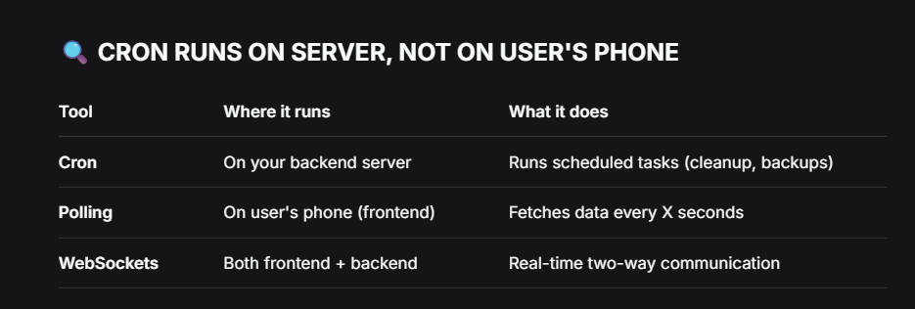

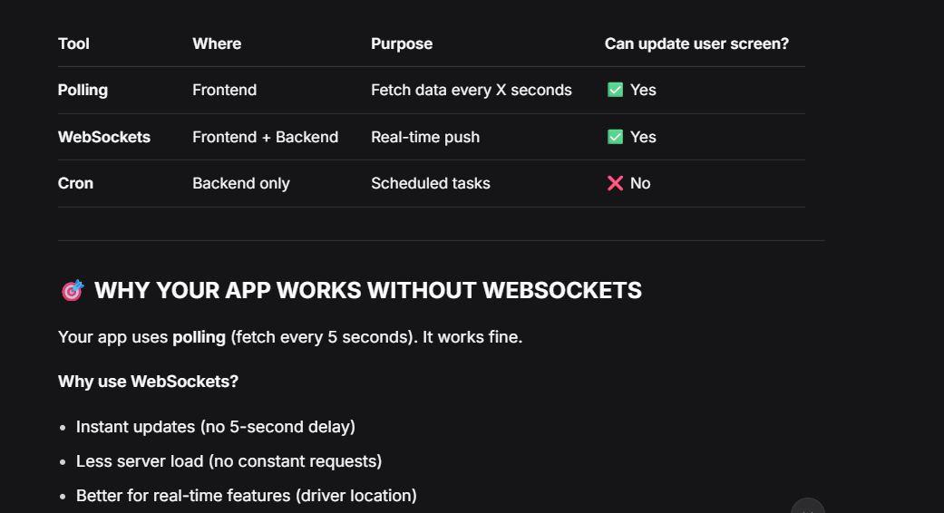

Added customer login cleanup behavior so on startup login and OTP login, customer open orders are auto-deleted.
Updated customer bid update rules by adding stricter conflict mapping that prevents lowering price, requires increase by at least 50, and increments of 50.
Added customer-side bid marketplace APIs including wrappers for open-order fetch, list bids, update bid, accept bid, and reject bid.
IImplemented customer dashboard bid flow with polling for incoming bids every second, accept and reject actions, customer bid update action, countdown handling, and open-order hydration from backend.
I improved expired bid UI cleanup so expired bids are pruned from visible list immediately at zero seconds, not just disabled.
Updated SQL-side bid lifecycle rules including 15-second bid validity, added remaining_seconds in customer bid list response, customer bid increment rules, and clearing old supplier bids after customer price update.
Also enforced supplier cooldown at runtime in backend controller by adding direct 15-second bid cooldown logic in controller path to avoid old DB-function behavior.

So for now, the code is working correctly till supplier timer state.

14/04/2026:
UI timer maybe a little off but the actual timeout will be checked on database on specific fns like accept order, send a new bid, etc
So timer phase is working well.
Polling is working well. So far.
Need to check , whether the same order is shown on customer side on logout or direct closing application
Same on supplier side in active orders status.

20/04/2026:
To start application in uni:
  - Use direct pooler as hotspot supports ipv6
  - Update the ip address (ipconfig)

21/04/2026:
Added api fns for assigning drivers to orders , get assignable drivers, and cancel order
Auto navigation for supplier dashboard on login so that if he has an active order WHICH is on supplier timer then re-direct him to that page insated of live market
Same when the customer first accepts the order.
Basic order details are shown

On driver side, currently he has to refresh to view new assigned orders to him. He can accept or reject that order after confirmation.
He has to do it in driver_timer = 60 seconds or the remaining supplier_timer (max : 5 minutes)
The lesser of the two , when finished , will trgger order cancellation
Timer is shown on frontend

The whole timer part is consistent and implemented in SQL only, not in JS.
Throughout the whole process, cancel order is available for customer and supplier.

Driver availability is intentionally set to false in two places: when a driver accepts an order and when they explicitly log out. App close without logout leaves them available, which is intentional and matches Uber and Bykea behavior since there is no reliable way to detect app closure.
Driver who rejects an order gets `order_rejected = TRUE` in the driver assignment table, causing the supplier to see them as rejected and greyed out, while the `assign_driver_to_order` function blocks reassignment to the same order, though they can still be assigned to other orders.
Upon order acceptance, all the role’s UI are updated with order details.

25/04/2026:
Added customer history and rating feature set including API calls for GET customer history, GET customer history by order ID, and POST customer order rating. Updated customer history detail response in startupController.js to include order_id and customer_rating from order_history. Added full History tab, details screen, and rating UI in CustomerDashboard.js.
Added supplier view details before bidding feature including API call for GET supplier orders available by order ID. Added market detail flow in SupplierDashboard.js with view button opening full detail page, bid submission supported there, and 403 handling shown when supplier has no available linked drivers.
Added driver confirmation and completion UX including accept and reject confirmation alerts and driver completion receipt modal in DriverDashboard.js.

Implemented area and district handling at order creation by adding Karachi area dropdown in CustomerDashboard.js and storing delivery_location as address comma area and also modified live market layout and area-only display by adding delivery_location to supplier market list SQL so that each card showed area parsed from delivery_location instead of full address.

Added rating prompt modal logic in CustomerDashboard.js that shows rating modal automatically, allows not now option dismissing for current app session only, and submits rating from modal.

So far testing is working as well as the UI. Obviously more testing to do but can potentially say that the app is completed.
I revert back, the frontend’s functionality is complete.

13/05/2026:
Doing minor checks.
After completing an order, customer was not reverting to the create order screen. Fixed.
On completion of order, after pressing not now on submit rating pop up and logging out, the customer was getting the same pop up when logging back in. Fixed.
Driver was getting order details on the bottom of the screen after pressing view details for a past order. Fixed it. Now shows it on a new page.
Supplier had no button for viewing past orders. Added that and the details tab.
Added polling on driver dashboard to automatically refresh and find new assignments

